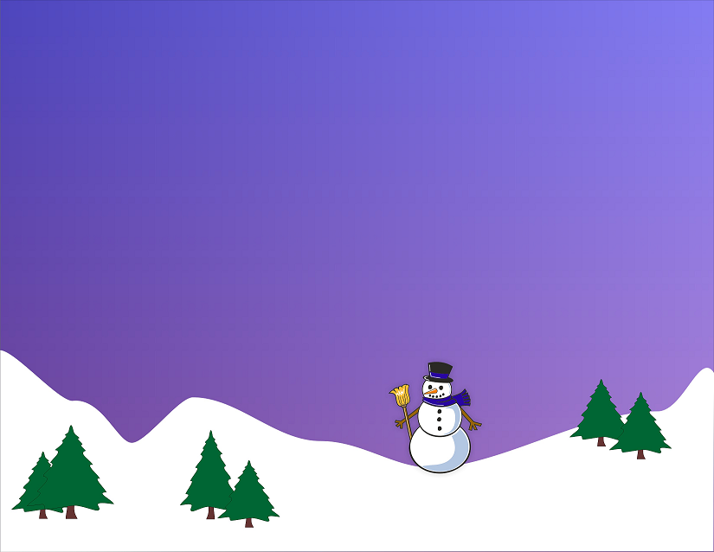
Happy Holidays
Dear ,
Thank you very much for the . It was just what I wanted and is definitely a very thoughtful gift; I am looking forward to using it soon. Thank you!
I hope you had very happy holidays and thanks again for the fantastic gift! Happy New Year!

Best Regards,
Me
Happy Holidays
Dear ,
Thank you very much for the . It was just what I wanted and is definitely a very thoughtful gift; I am looking forward to using it soon. Thank you!
I hope you had very happy holidays and thanks again for the fantastic gift! Happy New Year!

Best Regards,
Me
Happy Holidays
Dear ,
Thank you very much for the . It was just what I wanted and is definitely a very thoughtful gift; I am looking forward to using it soon. Thank you!
I hope you had very happy holidays and thanks again for the fantastic gift! Happy New Year!

Best Regards,
Me

